Date: 10/03/20 I S T LM TA
Context: This week we have been learning to take-away. To help us with this new skill we have been practicing counting backwards. Today the children will count backwards from 10 and fill in the missing numbers.
Learning Objective:  *To count back from a given number.  *To say one less than a number. | Success Criteria:  I can count back from 10.  I can say the number that is 1 less.  I can write my numbers correctly.
Next Steps:
Can you help me count backwards from 10 to fill in the missing numbers.

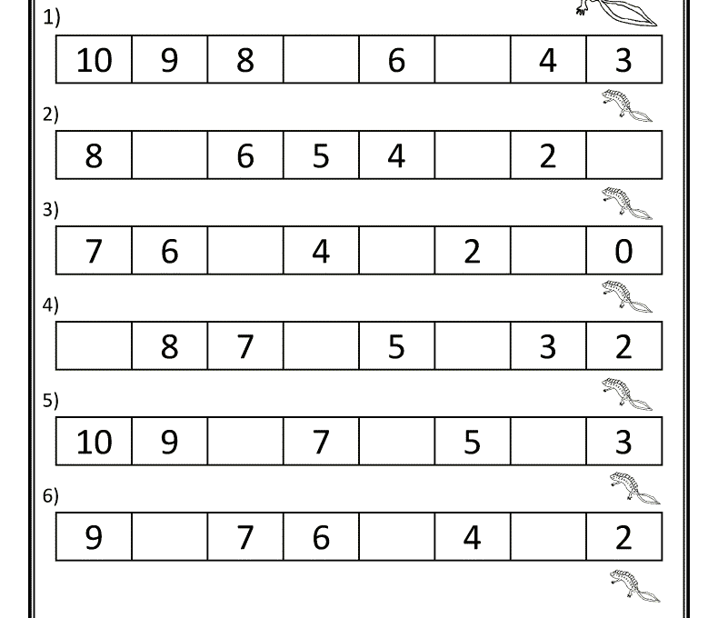

Date: 11/03/20 I S T LM TA
Context: This week we have been learning to take-away. To help us with this new skill we have been practicing counting backwards. Today the children will count backwards from 10 and fill in the missing numbers.
Learning Objective:  *To count back from a given number.  *To say one less than a number. | Success Criteria:  I can count back from 10.  I can say the number that is 1 less.  I can write my numbers correctly.
Next Steps:
Count to 20 and then cut and stick the numbers in order.

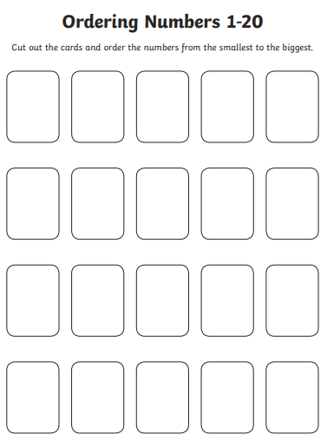

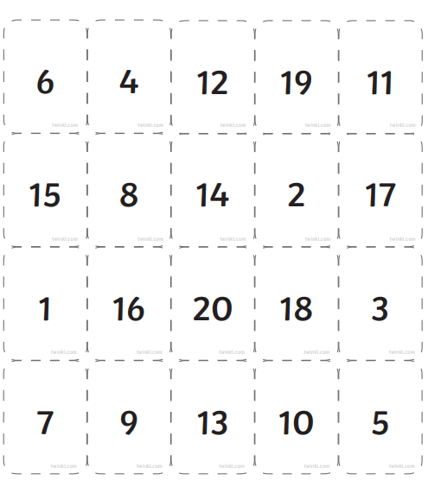
Numbers to Cut and Stick on 11/03/20

